**Classifying Baseball Swing Patterns Using Computer Vision: Neural Networks/Deep Learning**

**Summary:**

The purpose of this project was to utilize computer vision techniques to identify and group baseball swing patterns. There are many steps to a baseball swing, which may make it difficult for a human eye to detect every swing pattern. In addition, tabulating and characterizing swing patterns can be time consuming and tedious. Neural networks and deep learning models can be used in baseball applications to detect swing patterns, body kinematics, or even predict dangerous movements that could cause injury. Due to time constraints, and computing processing power, this study is limited to detecting two types of swings: 1) A swing where the batter casts his/her hands and has an “over the top” swing. 2) An “inside out” swing. Matlab was the program used during the scope of this project.

**Discussion:**

The first step of this project was to determine the necessary neural network structure for video classification. There are many pre-trained neural networks in Matlab that can be used to train new sets of data. Instead of building a network from scratch, pre-trained networks can be tuned for different applications. For this project, a pre-trained convolutional network called GoogLeNet was used in conjunction with a Long Short Term Memory (LSTM) network. GoogLeNet is a pretrained image classification model, and the LSTM network was designed to assist in classifying a sequence of images (frames in a video).

I began by taking 10 videos of each swing and using these as input data into the model. The program uses 70% of the videos (14) as training data and the other 30% (6) as validation data. The program will train the neural network based on these videos. Figure 1 below shows the results of the training performance.

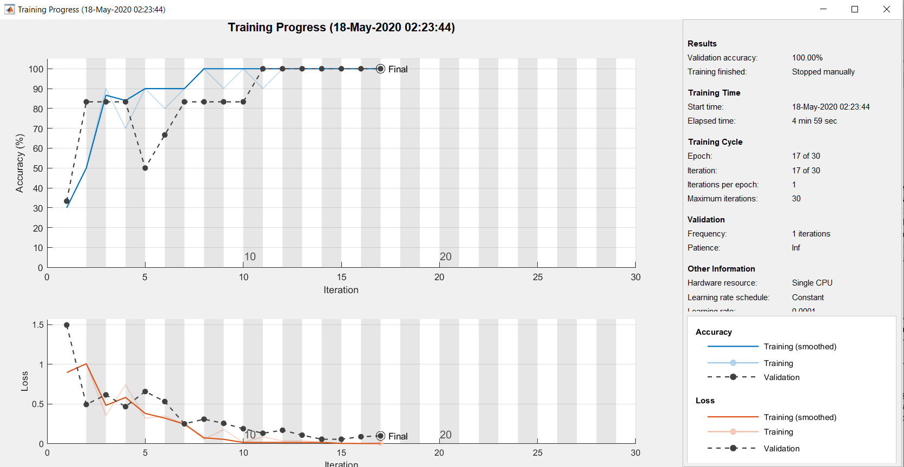

Figure 1: Neural Network Training Progress

I manually stopped the training at iteration 17 of 30 because the validation was steady at 100%. After training the model, I then tested 4 swing videos (2 “over the top” and 2 “inside out” swings) to see if the network could correctly classify the two swing types. The model correctly classified the two “casting hands” swings and the two “inside out” swings. The video below demonstrates the results.

The title of each video is the classification result of the neural network. In other words, if the network classified the test video as a “casting hands” swing, then the title will be “casting hands swing.”



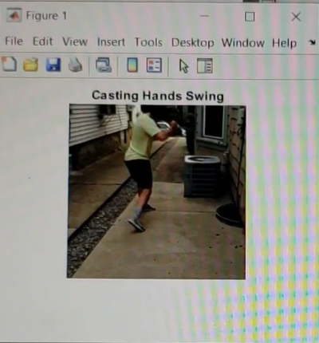 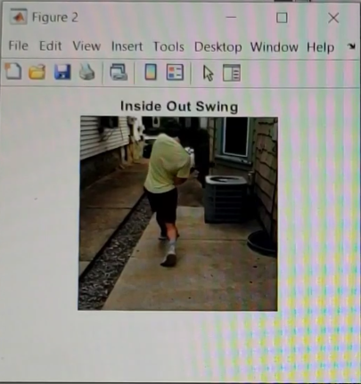

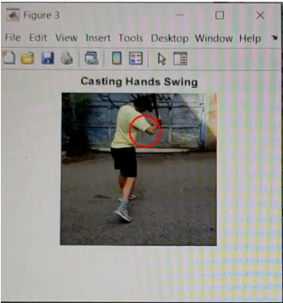 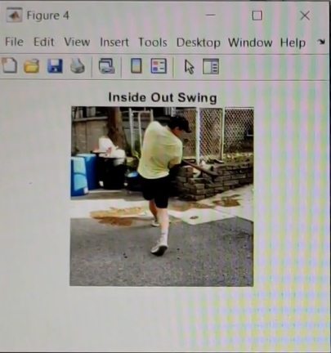

**Conclusions:**

Though the model correctly classified the two test swings that I used, it struggled to classify swings that were more unique. There were some restraints within this project that may have caused some of the inconsistencies. Some of the problems I encountered during this project are noted in the following bullet points.

* CPU processing power – Due to the limited amount of processing power in my laptop, I was limited on the amount of input data and type of pre-trained neural network I could use.
  + Limited amount of input data – The more input data the model has, the more robust and accurate the training will be. More input data could have produced better results.
* Time – Training the neural network consumes a lot of time. The neural network needed re-trained for any change to the input data or parameters.
* Knowledge – Much of the time used during this project was spent learning the ins and outs of computer vision, deep learning, and Matlab tools. Once I gained an understanding of these concepts, applying them to baseball situations was easy and enjoyable.

There are endless amounts of computer vision applications in baseball. Some ideas that can be explored further are swing and pitching habits over time, directional body movements, speed of movements, body position angles during a swing or pitch, and detecting swing or pitching faults. For example, injuries can be prevented by using a computer vision model to detect dangerous arm angles during one’s delivery. Another example is using swing pattern data to get out of a slump. A computer vision model can observe swing patterns over time, and notice differences if a swing changes. Computer vision and machine learning demonstrate how technology can greatly enhance the game of baseball.